Heuristic Re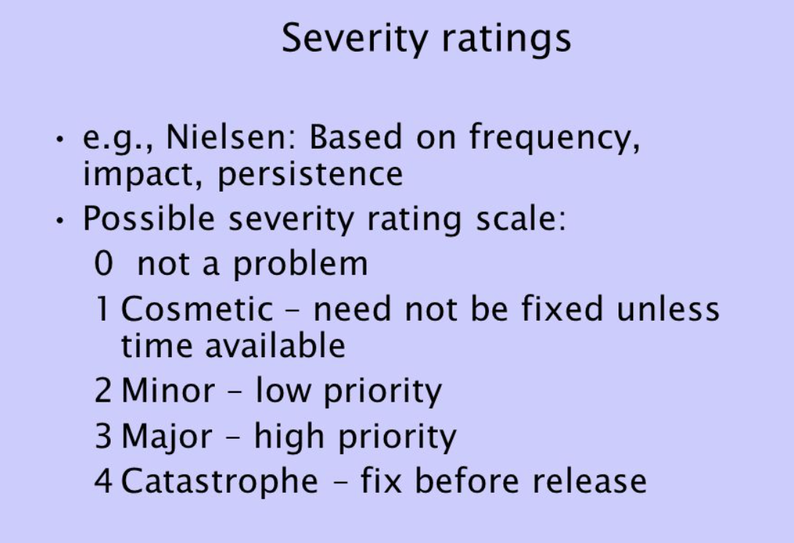view

|  |  |  |  |
| --- | --- | --- | --- |
| **Reviewer No. :** | | | |
| **Reviewer’s name :** | | | |
|  | | | |
| **Issue :** | | | |
|  | | | |
| **Severity Level** | **Location** | **Issues** | **Recommendations** |
|  |  |  |  |
|  |  |  |  |
|  |  |  |  |
|  |  |  |  |
|  |  |  |  |
|  |  |  |  |

Example

|  |  |  |  |
| --- | --- | --- | --- |
| **Reviewer No. : 1** | | | |
| **Reviewer’s name : Hari Bahadur** | | | |
|  | | | |
| **Issue : Consistency and Standards** | | | |
|  | | | |
| **Severity Level** | **Location** | **Issues** | **Recommendations** |
|  |  |  |  |
| 2 | Profile Page | Users details are not available | Users details must be provided along with update option |
|  |  |  |  |
| 3 | Food Order Page | The drop down is not convenient | Users should be able to enter quantity directly |
|  |  |  |  |
| 1 | Log Out Page | The icon is not clear and can confuse novice users | Icon should be labelled appropriately for clear information |